|  |  |
| --- | --- |
| Name | Mohand haithem Ahmed |
| Unit | 6 |
| Date | 28/11/2024 |
| Task | 2 |

Explanations of HTML Code for "Security Systems" Website

Following is the HTML code that gives the structure and content of the webpage for a company named "Security Systems." Its breakdown:

_____________________________________________________________

User requirement

**User Requirements for Security System**

1. **Objective:** The security system should provide comprehensive protection for the premises, ensuring safety and monitoring of all access points. The system will include surveillance cameras, intrusion detection sensors, and emergency alerts.
2. **Number of pages : user need 4 pages**
3. **header**
4. **products**
5. **contact**
6. **login**

**2. Key Requirements:**

* **Surveillance:**
  + High-definition cameras for indoor and outdoor monitoring.
  + 24/7 recording with motion detection capability.
  + Remote access to live footage and recordings via mobile or desktop devices.
  + Night vision for low-light conditions.
* **Intrusion Detection:**
  + Door/window sensors for entry points.
  + Motion sensors in critical areas.
  + Real-time alerts via app notifications or SMS in case of security breach.
* **User Interface:**
  + Easy-to-use mobile app and web interface for monitoring and control.
  + Multi-user access with different permission levels (e.g., Admin, User).
  + Ability to integrate with existing home automation systems (optional).
* **Emergency Alerts:**
  + Automatic alerts sent to security personnel or local authorities in case of break-ins or emergencies.
  + Integration with alarm systems to sound sirens upon detection of threats.
* **Data Privacy and Security:**
  + Encrypted video storage and transmission.
  + User data must be kept private and not shared without consent.
  + Multi-factor authentication for accessing the system.
* **System Reliability:**
  + Redundancy in power supply (backup battery) for uninterrupted service.
  + Continuous system operation even in case of network failures.
* **Customization:**
  + Adjustable settings for alerts, sensors, and cameras.
  + Option to schedule times when the system should be active or in "Away Mode."
* **Maintenance and Support:**
  + Regular software updates to address vulnerabilities.
  + 24/7 customer support for troubleshooting and technical assistance.

**3. Technical Specifications:**

* Operating System Compatibility: Windows, iOS, Android
* Camera Resolution: Minimum 1080p Full HD
* Sensor Type: Motion detectors, door/window contact sensors
* Connectivity: Wi-Fi, Ethernet, or GSM (optional)

The user need to change the background from there :

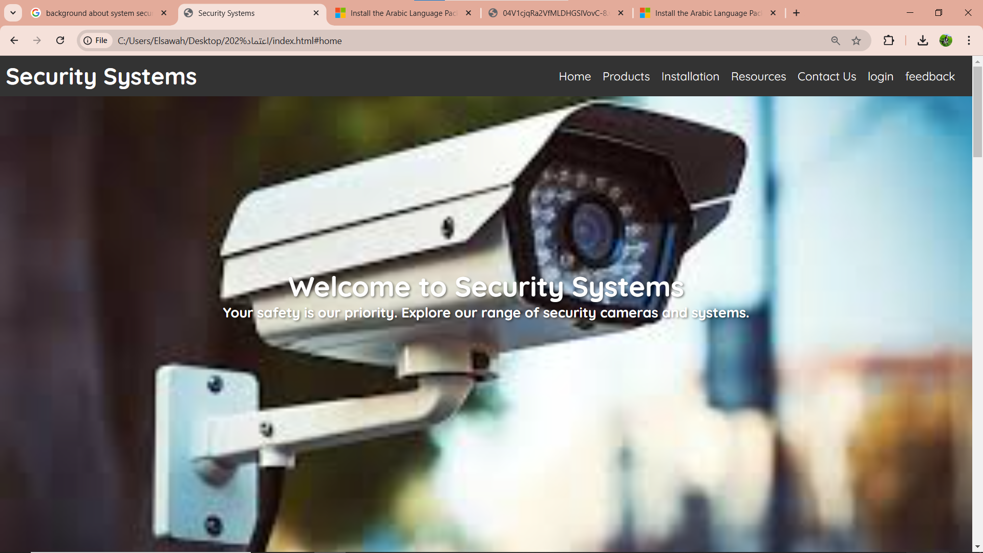

To put this picture :

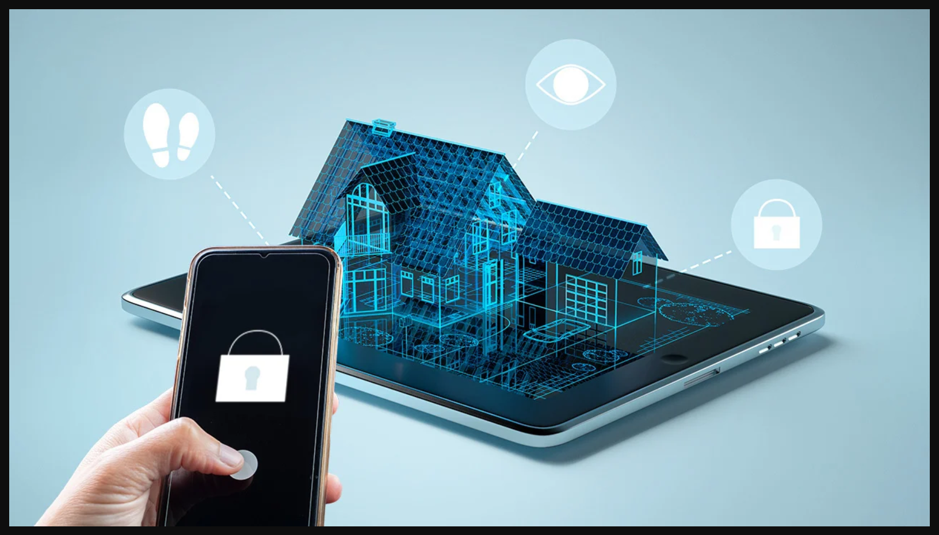

And done successfully and this is the final result :

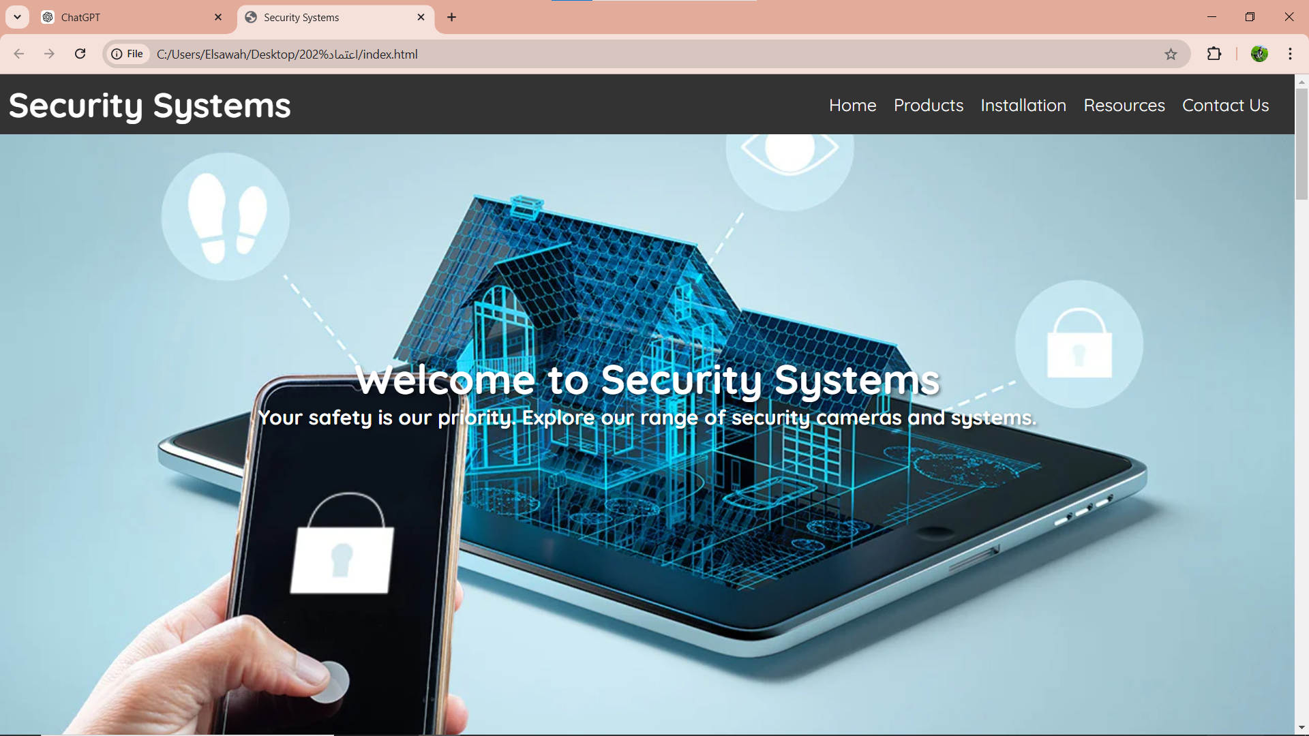

The user need to change the background color in the contact section from black to gray :

And done successfully

Final result is :



1. Header Section



• Header: This includes a navbar showing the name of the website, and also links to other parts of the page:

o Home

o\products

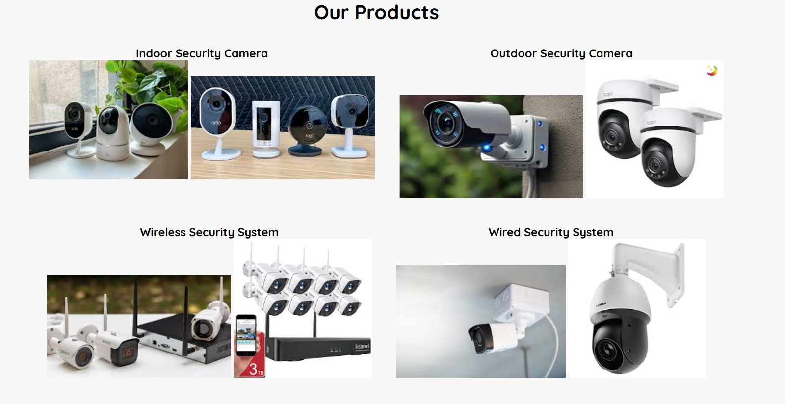

Installation

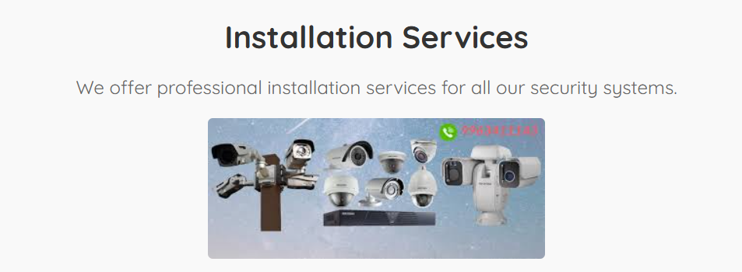

Resources

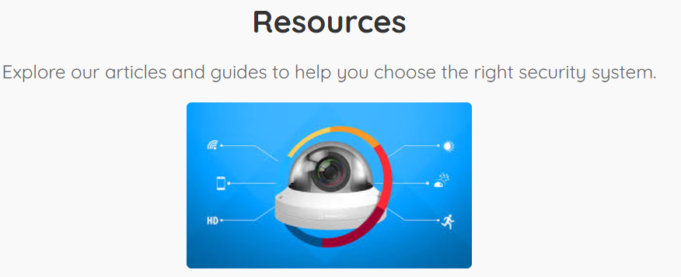

Contact Us

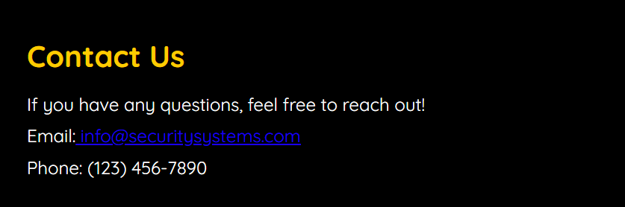

______________________________________

2. Main Content

The old text falls into several categories:

a. Home Section

• An introductory message welcomes users to the website and introduces the company working on security systems.

b. Product Section

• Products dealing offered by the company in the following aspects:

* Indoor Security Camera

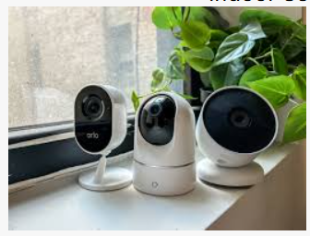

* Outdoor Security Camera

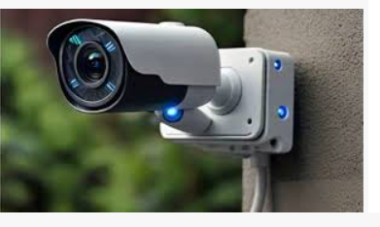

wireless security system

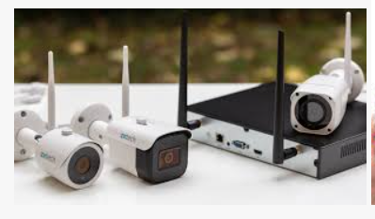

o\wired Security System

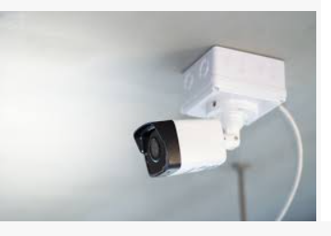

• All of them are located in the folder named imgs.

c. Installation Services

• It includes professional installation for every security system.

•includes an image that illustrates the service.

d. Means

• Provides access to various articles and guides on the selection of appropriate security systems.

This involves a diagram about the resources.

e. Contact us



• Provides contact details about the company:

o\email address: info@securitysystems.com

o Phone number: (123) 456-7890

f. Introduction Section

• He shall allow the user to login into his account using username and password via a form.

• There is a link to the sign-up page for new users.

g. Feedback Section

• A customer feedback form based on the following:

o Names

o\tEmail

o\tFeedback message

• Contains a SUBMIT button.

h. Customer' Comments

Added customer testimonials together with feedback quotes and names.

_____________________________________________

1. Footer Section



• Copyright notice present:

© 2023 Security Systems. All rights reserved.

_________________________________________

Additional Comments

• An external CSS that styles this webpage; named style.css.

• Pictures go in the imgs folder and are brought in via the <img> tag.

• Proper semantic elements (<header>, <section>, <footer>) are used to organize the content.

• There's navigation between different sections using id and links provided in a navigation bar.

_________________________________________

Improvements by Members

• Make sure all images are linked correctly and present within the given folder.

•　More informative ALT text in describing graphics to increase accessibility.

• There are duplicated sections, for example, "What Our Customers Say".

This is the HTML structure representing a clean, functional design for the "Security Systems" website, with user-friendly, visually ordered elements.

CSS

1. General Styles

• Universal Selector (*)

o All margin and padding is set to 0, also box-sizing is set to border-box.

o Implement smooth scrolling behavior across the page using scroll-behavior: smooth;.

• HTML WebFont

o font-family: "Quicksand"; This font is modern and neat. Will be imported from Google Fonts.

__________________________________________

2. Navigation Bar (navbar)

• Top of the page, The value of position is fixed. Full width width 100%.

• Styled on DARK background, background-color #333, text should be in white.

• Links (<a>) are in yellow on hover for transition effects smoothly.

_______________________________________

3. Home Section

•: Uses a background image with a darkened overlay for readability using ::before pseudo-element with semi-transparent black color.

• The text is aligned to the center, large, bold, and has text shadow.

_____________________________

4. Product Section

• . flex-wrap: wrap; displays the products in a responsive flex-wrap manner.

• position is relative and background-color is #f7f7f7;.

_________________________________________

5. Feedback Sheet

• Filled in a neat format.

o Card-like appearing: using of border-radius for rounded corners; box-shadow for slight shadow of it.

o Hover effects are clear on input fields and buttons for interactivity.

__________________________________________

6. Customers' Feedback Section

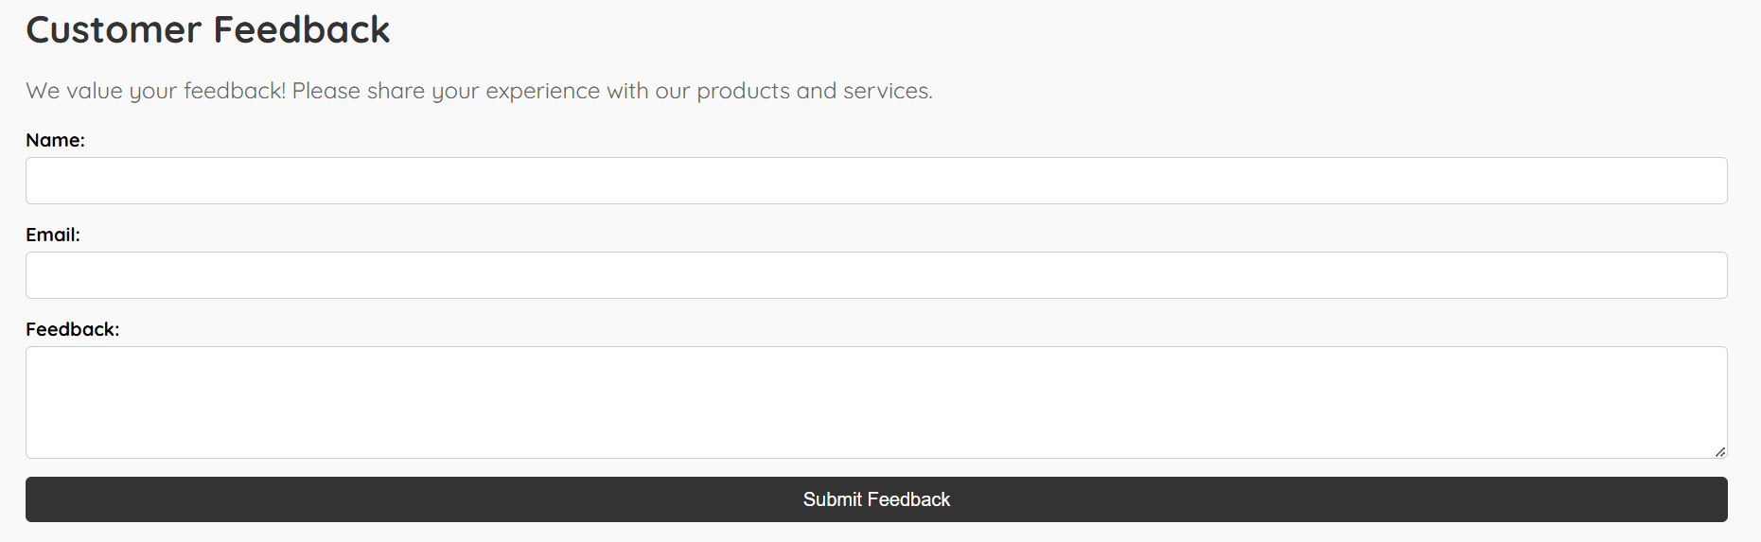

• Customer testimonials can be displayed in an orderly block display:

o Highlights quotations with a yellow left border (border-left: 4px solid #ffcc00 ).

_________________________________________

7. Installation and Resources Sections

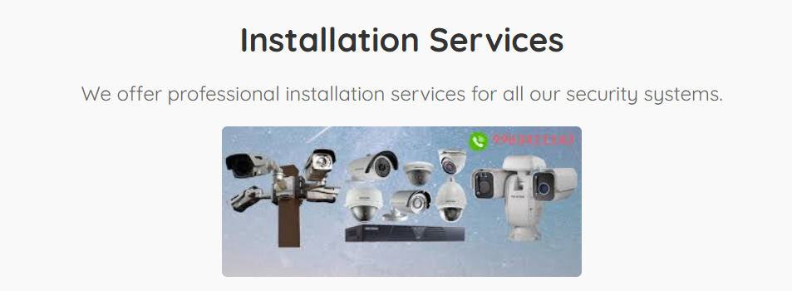

• Both paragraphs are aligned:

It gives a decent look to the background color. Faded shadow.

Responsive images: max-width: 100%; height: auto;.

_______________________________________

8. Contact Section

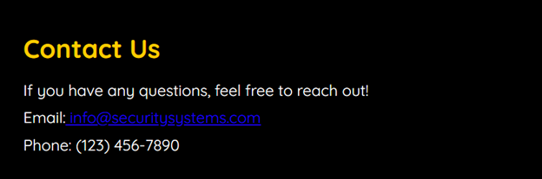

High Contrast Black background with Yellow being used for headings.

The e-mail links are in blue and underlined for better identification.

_______________________________________________________

9. Log-in Section

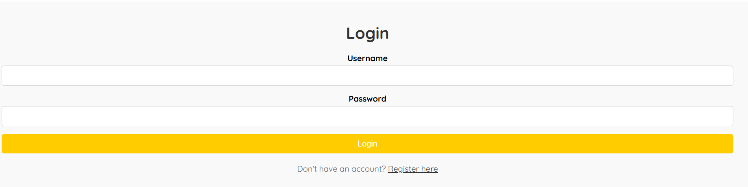

• The form's layout is centered, with clearly labelled input fields.

• Design buttons and links for maximum readability and usability.

_________________________________________

10. Media Queries, Responsive Design

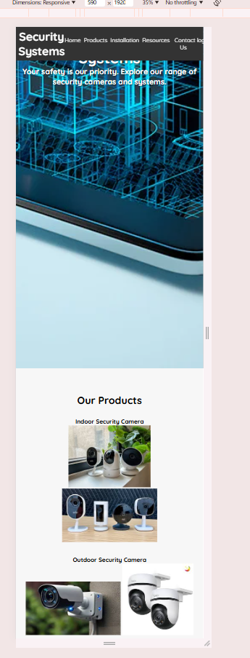

• Website adapted for small screens with max-width: 768px:

o\navigation links align vertically.

o\product images and sections self-align for proper viewing.

Attention.

Key Features

• Type-setting

o Consistent font sizes and weights enhance readability.

• Color:

black dark grays, whites and yellows provide the most professional, accessible design.

• Interactivity:

o Hover effects enhance users' experiences.



• Responsive Design:

o Ensures usability for multiple devices

CSS to beautify the following code; making this responsive, so that a "Security Systems" website would look professional on every screen size.